The Eden Estuary Game 3-8 players
Rule and preparation Booklet 1-2 hours
Game Overview
Game components
- Tokens
  - 10 Conservation Program Tokens (Green)
  - 10 Agricultural Developments Tokens (Yellow)
  - 10 Tourism Development Tokens (Blue)
  - 10 Disaster Risk Reduction Tokens (Orange)
  - 3 Disaster Relief Tokens (Black)
  - 17 Hazards Tokens (Red)
- Map of the Eden Estuary
- 8 Actor Cards
- 27 Hazard Cards

You have been elected to represent your community’s interest at the new board of the Eden Estuary. Due to climate change the area is experiencing environmental stress leading to economic, environmental, and social hazards. By collaborating with the various actors of the board you will need to ensure the stability of the estuary, while ensuring its development. As a team, the board will be responsible for deciding where development resources should be implemented and when. It will need to determine what type of deployment would be most efficient, whether it is conservation, tourism, or agriculture. Through collaborative work you will need to represent your sector whilst ensuring the prosperity of the area and avoid a crisis.
The Eden Estuary
The Eden Estuary is located in Fife, Scotland. It is known for its diversity in fauna and flora and is used for a vast number of recreational activities such as bird watching, walking or horse-riding (Fife Coast & Countryside trust, 2023). Unfortunately, erosion and flood risks are growing concern for the Eden Estuary and is affecting the communities living in the area (Rennie et al, 2021). Additionally, these changes in the environment are threatening fragile ecosystem such as coastal habitats (Cunningham & Hunt, 2023) and the biodiversity (Fife Biodiversity Partnership, 2013). Furthermore, the area is also experiencing a rise in poverty (Fife.gov,2023) whilst the economy is developing (Corbett &Laughlin, 2022). Ensuring sustainable management of the area would enable to limit hazards and ensure a stable environment, social and economic future.
Objective of the game
The board’s (collective objective):
- The board’s objective is to complete all 5 rounds without undergoing a crisis.
The actor’s (individual objective):
- Each actor objective is to score the most points. The way to score points will vary depending on the actor.
Setup
- Cut the tokens and the hazard cards
- Place the map in the centre so that all players can see it.
- Place the tokens on the table, grouping them by colour.
- Shuffle the hazard cards and place them in a pile, facing down, next to the map.
- Designate a player to represent Fife council and give them the Fife Council actor card.
- Randomly distribute an actor card to every other player.
- Before and playing the game it would be great if every participants could complete a survey! The link to those will be given in the form of a QR code.
Figure 1 Pre session
Figure 2 Post Session

Core Tokens
Conservation programs
Conservation programs seek to protect and preserve the surrounding nature and biodiversity (e.g. creating protected areas, raising environmental awareness amongst surrounding communities, limiting light and noise pollution in specific areas). Conservation programs will help reduce biodiversity loss and ecosystem degradation, making the area more resilient to environmental hazards. However, it might compete with economic and social factors.
Agricultural development
Agricultural development aim to further develop the agricultural sector in the area (e.g. increasing farmland, increasing yield, creation of financial help for farmers). This development would help to bring further economic development as well as reduce tension amongst farmers. Nevertheless, this needs to be included cautiously as this could bring further pressure on the environment.
Tourism development
Tourism action aims to make the region known to the wider public and to develop its tourist attraction (e.g. increase of international events, increasing hotels and tourism infrastructures, developing travel infrastructure to enable easier access). Such development would enable to benefit the communities by developing the economy and making the area more active. However, this can be a double-knife edge as this could threaten the environment and too much tourism could cause social conflicts.
Disaster risk reduction
Disaster risk reduction aims to make the area more adaptable and resilient against threats (e.g. implementing coast infrastructure to decrease erosion, putting in place flooding procedures to limit social stress, developing hazard prediction and response strategies to limit repair costs). Disaster risk reduction enables to decrease the risk of hazards in the area.
Special Token: Disaster relief
Those enable to decrease the number of hazards per tile in order to avoid a crisis.

Playing the Game
End of game
If at any point during the 5 rounds any tile on the map has more than 5 hazards, then the area has reached a crisis, and the board has failed. This ends the game and all actors have lost. If the board succeeds in completing all 5 rounds without entering a crisis, players can calculate their final scores. The player with the most points wins.
Round Overview
The game is played in 5 rounds. In each round the board has 5 minute to discuss what they wish to do and play their actions. Up to 4 actions can be played every round (there is no obligation to play all 4). There are 4 different types of actions:
- Placing new tokens
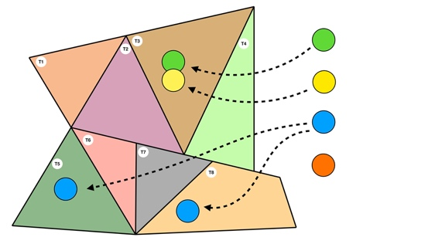
  - You can decide to place any core tokens on any tiles of the map. This can be done in any combination (all the same tokens or different tokens as well as multiple on one area or distributed throughout the whole map).
- Swapping placed tokens
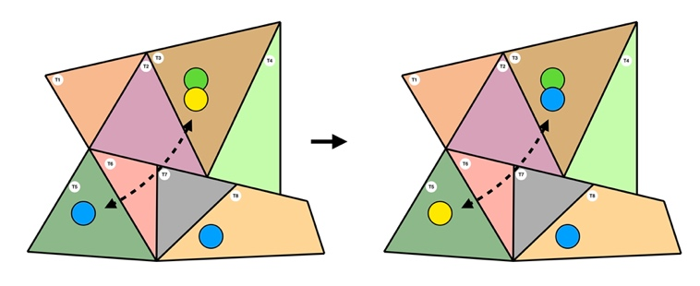
  - You can decide to exchange any core token that have already been placed on the map together.
- Swapping a placed token for a new type of action
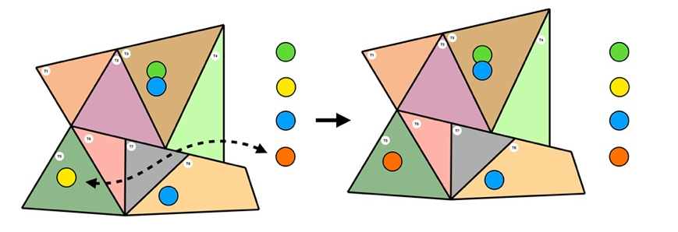
  - You can decide to swap a placed core token to another type of core token. For example, from an Agricultural Development token to a Disaster Risk Reduction token.
- Disaster relief tokens
  - Disaster relief tokens are special tokens that enable you to reduce the number of hazards on the map. Those can be played in two ways:
    - Placing it on a tile with 1-3 hazards
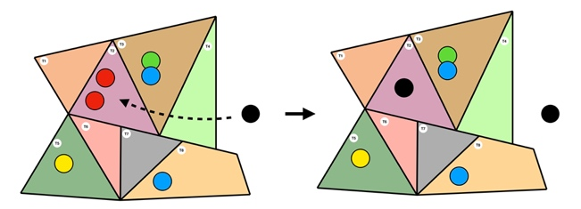
      - You can decide to place a disaster relief token on a tile with 1 or 3 hazards. This will enable you to take all the hazards away from the tile.
    - Placing it on a Tile with 4-5 hazards
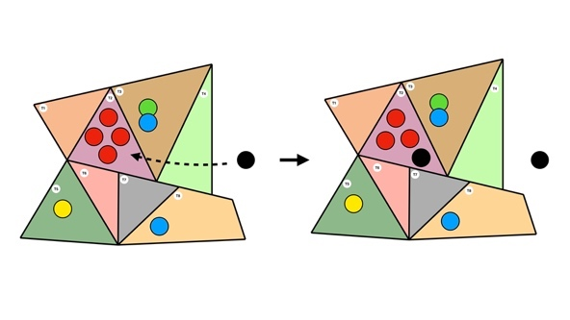
      - You can decide to place a disaster relief token on a tile with 3 hazards in order to avoid a crisis. However, in this case the disaster relief only enables to take 1 hazard off.
Note that you can decide to reclaim a disaster relief token, however in order to do this you must remove 4 core tokens from the map. At the end of the 5 minutes are completed and the board has achieved the actions it wished to do the first 3 Hazard Cards of the pile are revealed and read out loud. Those represents events and hazards that have taken place in the last 5 years. According to the Hazard cards the board needs to add hazards on the map After this each actor counts their points. This marks the end of a round.
Actors card
Actor cards describe the role of each actor and how they can win points throughout the game. Before the first round every player needs to be given a card, one player must always represent the Fife Council at every game. Players discover their role and make the board aware of who they are. Players decide how much they want to be transparent about their goals, depending on the strategy they wish to adopt.
Royal air force Leuchars
- You are a commander at Leuchars Diversion Airfield. Your role as a member of the board is to represent the interest of the Royal Air Force Leuchars base. Your main objective is to ensure the stability of the area and restrict the amount of hazard as this could put your operations to risk (Royal Air Force, 2023). To achieve this, implementing Conservation initiatives in the area surrounding the airfield could ensure to limit leisure activities around the base which could become a security hazard. Additionally, developing the area’s economy through tourism and agriculture, can ensure social stability and reduce local tensions.
- In order to reach your goal, you will need to balance the development of the area whilst ensuring that this will not limit the royal air force activities. Whilst you do not have direct interest in the board, the decision made there will indirectly affect the base, for example an increase in tourism could increase the population of the area and increase land competition, this might strengthen policies and limit your ability to practice diverse missions in the area. Therefore, you will need to collaborate and create links with the various actors to ensure that decisions will benefit your sector.
Points accounted for at the end of every round
- Gain 4 points per Conservation Program token placed on a tile with the Royal Air Force Leuchars (T2, T3)
- Gain 3 points per Disaster Risk Reduction token placed on tiles with road infrastructure (T1, T2, T4, T8).
- Gain 2 points per Agricultural Development token placed on the map.
- Gain 2 points per Tourism Development token placed on the map.
- Lose 1 point per Hazard on the map.
End of game points
- Lose 5 points per Disaster Relief token on a tile with the Royal Air Force Leuchars (T2, T3)
- Lose 2 points per Hazard placed on a tile with the Royal Air Force Leuchars (T2, T3)
- Lose 1 point per tiles with road infrastructures and NO Disaster Risk Reduction token (T1, T2, T4, T8).
- Lose 1 point per tile with the Royal Air Force Leuchars and a Tourism Development token (T2, T3)
Points per round |  |  |  |  |  | End of game points | Total points (Total round point + end of game points)
1 | 2 | 3 | 4 | 5 | Total
Space for calculations |  |  |  |  |  | Types of tokens:  - Conservation Program  - Agricultural Development  - Tourism development  - Disaster Risk Reduction  - Disaster relief  - Hazard token

Local community representative
- You have been elected to represent the population living in this specific area of Fife. Your main objective is to ensure the wellbeing of the population whether that is socially, economically, or environmentally. You represent the population’s needs, wants, and demands. Those include ensuring equitable opportunities for all, increasing cultural and environmental initiatives, ensuring inclusive growth and jobs, and providing community led services (Fife Council, 2022). In order to achieve this, you will need to ensure tourism and agricultural development and conservation programs. However, in the long-term, this is a double-edge knife as too much of those could cause social tensions, a vulnerable economy, and environmental degradation. For example, tourism could bring visibility, develop the economy and lead to diversity but too much could lead to mass tourism which degrade the environment, causes tensions between tourist and locals, and cause the area to become economically dependent on one sector.
- You will need to participate and collaborate closely with the board in order to ensure that your view is heard and taken in account through decision making. You must ensure that the development is done sustainably and benefits the local population.
Points accounted for at the end of every round
- Gain 3 points per Agricultural token on the map.
- Gain 3 points per Tourism Development token on the map.
- Gain 2 points per Disaster Risk Reduction token on the map.
- Gain 2 points per Conservation Program token in the area.
- Lose 1 point per Hazard on a tile with road infrastructure (T1, T2, T4, T8).
End of game points
- Lose 5 points per tile with a town and NO Disaster Risk Reduction Token (T1, T2, T6, T7, T8).
- Lose 3 points per Hazard placed in a tile with a town (T1, T2, T6, T7, T8).
- Lose 1 point per Tourism Development on a tile with a town (T1, T2, T6, T7, T8).
Points per round |  |  |  |  |  | End of game points | Total points (Total round point + end of game points)
1 | 2 | 3 | 4 | 5 | Total
Space for calculations |  |  |  |  |  | Types of tokens:  - Conservation Program  - Agricultural Development  - Tourism development  - Disaster Risk Reduction  - Disaster relief  - Hazard token

Leader of Fife council
- As the representative of the Fife council, you have the responsibility of representing the view of the council and work towards the cabinet program and priorities. Your decision process needs to be guided by two main objectives. Firstly, social equity, economic development and coping with climate change, secondly assuring positive political feedback. Your aim is to balance those two goals and avoid conflicts of interest. To reach your objective you must engage with the different actors, including local community, conservation organisations and the private sector.
- Above all prioritising economic development through tourism and agricultural expansion will enable you to ensure the short-term prosperity of the area by creating business opportunities and stimulating the region’s economy (Fife Council, 2023). This will generate positive political views amongst the population enabling to maintain political power and influence. Simultaneously, you need to ensure that the economic sector is working along with conservation initiatives in order to reduce environmental hazard. This will be critical for the Eden Estuary in the long-term in order to ensure environmental stability of the area and this will boost your reputation. Working along with agricultural activities will demonstrate a political leader which is close to its people. However, focusing too much on certain objectives might overshadow others and cause stress in other activities. Furthermore, avoiding the use of disaster relief is essential for. You as such actions require large number of resources.
Points accounted for at the end of every round
- Gain 3 points per Tourism Development token on the map.
- Gain 3 points per Agricultural Development token on the map.
- Gain 3 points per Conservation Program token on the map.
- Gain 2 points per Disaster Risk Reduction token played.
- Lose 1 point per Hazard on the map.
End of game points
- Lose 5 points per Disaster Relief token that has been played.
- Lose 2 points per Hazard on a tile with a town (T1, T2, T6, T7, T8).
- Lose 1 point per tile with a town and NO Conservation Program token (T1, T2, T6, T7, T8).
Points per round |  |  |  |  |  | End of game points | Total points (Total round point + end of game points)
1 | 2 | 3 | 4 | 5 | Total
Space for calculations |  |  |  |  |  | Types of tokens:  - Conservation Program  - Agricultural Development  - Tourism development  - Disaster Risk Reduction  - Disaster relief  - Hazard token
National Farmer Union Scotland (NFU Scotland)
- As the secretary of Fife of NFU Scotland you represent the farmers in Fife, your aim is to advocate for their rights and strive for the development of the sector (NFU Scotland, 2023). Your main aim is to develop agriculture production, particularly of soft fruits and vegetable which production is highly present in Fife (NatureScot, 2020), and make agriculture more profitable for farmers. Although sustainability and the protection of nature is part of the NFU Scotland concerns, your main priority is the development of farming. In the long-term, the development of the economy through farming will enable to increase the funds available for the protection of the Eden Estuary.
- Your main strategy is to convince the board of the importance of agricultural development in order to ensure the stability of the Eden Estuary and insure sustainable development in the future. However, it is important to engage with the other actors and collaborate on issues that might derail from your agenda. This might bring unexpected benefits to your industry (e.g. Nature conservation could help farmers to adapt to climate change and reduce cost on hazard repairs). The implementation of disaster risk reduction will also make your industry safer and limit risk hazards. Furthermore, you must ensure the creation of a trust relationship with the tourism industry to limit land competition and tensions.
Points accounted for at the end of every round.
- Gain 4 points per Agricultural Development token on tiles with farmland (T1, T5, T6, T7).
- Gain 2 points per Disaster Risk Reduction token played on tiles with farmland (T1, T5, T6, T7).
- Gain 1 point per Conservation Program token located on a tile with farmland (T1, T5, T6, T7).
- Gain 1 point per Disaster risk reduction on tile with road infrastructure (T1, T2, T4, T8).
End of game points
- Lose 4 points per tile with farmland but NO Agricultural Development token (T1, T5, T6, T7).
- Lose 2 points per Hazard on a tile with farmland (T1, T5, T6, T7).
- Lose 1 point per Tourism Development token on tiles with farmland (T1, T5, T6, T7).
- Lose 1 point per tiles with a farmland and NO Conservation program token (T1, T5, T6, T7).
Points per round |  |  |  |  |  | End of game points | Total points (Total round point + end of game points)
1 | 2 | 3 | 4 | 5 | Total
Space for calculations |  |  |  |  |  | Types of tokens:  - Conservation Program  - Agricultural Development  - Tourism development  - Disaster Risk Reduction  - Disaster relief  - Hazard token

Representant of University of St Andrews
- You are the Deputy Principal and Vice-Principal for International Strategy and External Relations for the University of St Andrews. Your main goal is to ensure the development of the university, revise its future strategy and work with local and international organisations (University of St Andrews, 2023). You want to insure the economic development of the area as well as the wellbeing of staff and students. It is crucial for you to fulfil your yearly academic objectives, however, simultaneously you need to think ahead of time and ensure the prosperity of the area in the long-term as this will highly benefit your sector.
- In order to achieve this, you will ned to ensure tourism development in the area as this will develop the economic sector and increase the visibility of the university. Working with conservation programs will also enable you to fulfil your sustainability measures. You will need to emphasise on your sector’s ability to benefit the area socially (by bringing an active population to the area and developing the educational sector), economically (creating jobs) and environmentally (sustainable development and conservation being a key part of the university’s development strategy).
Points accounted for at the end of every round.
- Gain 2 points per Tourism Development token placed on a tile with a town (T1, T2, T6, T7, T8).
- Gain 2 points per Disaster Risk Reduction token placed on tiles with road infrastructures (T1, T2, T4, T8).
- Gain 2 points per Conservation Program token placed on the map.
- Lose 1 point per Hazard on tiles with road infrastructures (T1, T2, T4, T8).
End of game points
- Lose 3 points per Hazard on St Andrews (T8)
- Lose 3 points per tiles with a town and NO Tourism Development (T1, T2, T6, T7, T8).
- Lose 3 points per tiles with road infrastructures and NO Disaster Risk Reduction token (T1, T2, T4, T8).
Points per round |  |  |  |  |  | End of game points | Total points (Total round point + end of game points)
1 | 2 | 3 | 4 | 5 | Total
Space for calculations |  |  |  |  |  | Types of tokens:  - Conservation Program  - Agricultural Development  - Tourism development  - Disaster Risk Reduction  - Disaster relief  - Hazard token

Fife Coast & Countryside Trust
- As the Head of operations of the Fife Coast & Countryside Trust you aim to conserve, manage, and protect the Eden Estuary. Your primary goal is to conserve the biodiversity of the area as well as collecting data on its wellbeing (Fife Coast & Countryside Trust, 2019). Additionally, you aim to protect the Eden Estuary from unsustainable use which are interictally linked to social and economic activities. Therefore, collaborating with local actors is especially important for you to promote more sustainable practices in farming and tourism such as reducing the use of irrigation and of pesticides and reducing the disruption of natural sites due to tourism. It is also important for you to understand how other activities could benefit conservation. For example, tourism development, could increase public awareness, increasing visibility which could increase protection movements and attract more conservation funds, however, this must be done cautiously. The presence of tourism in vulnerable areas could cause environmental stress and threaten the wellbeing of the ecosystem.
- You will therefore need to balance between the importance of protecting the Eden Estuary and ensuring sustainable practices while taking in account the importance of economic and social development. You will need to collaborate with the various actors to ensure that their needs are met while not jeopardising conservation efforts. You will need to engage with farmers and tourism businesses to ensure sustainable practices. Making your voice heard at the board might be complicated due to your focus on long-term benefits, which might be less obvious than short-term benefits of other industries. This might make it harder for other actors to understand the immediate value of your practices and make them more reluctant to invest in conservation.
Points accounted for at the end of every round.
- Gain 4 points per Conservation Program token on the map.
- Gain 2 points per Disaster Risk Reduction placed on a tile with the Eden Estuary (T2, T3, T4, T5, T6).
- Gain 1 point per Tourism Development token placed on a tile with the Eden Estuary (T2, T3, T4, T5, T6).
- Lose 1 point per Agricultural Development token on a tile with a forest (T3, T5, T6, T7).
End of game points
- Lose 5 points per tile with a forest and NO Conservation Program token (T3, T5, T6, T7).
- Lose 2 points per Tourism Development token on a tile with the Eden Estuary (T2, T3, T4, T5, T6).
- Lose 2 points per Hazard token on a tile with the Eden Estuary (T2, T3, T4, T5, T6).
Points per round |  |  |  |  |  | End of game points | Total points (Total round point + end of game points)
1 | 2 | 3 | 4 | 5 | Total
Space for calculations |  |  |  |  |  | Types of tokens:  - Conservation Program  - Agricultural Development  - Tourism development  - Disaster Risk Reduction  - Disaster relief  - Hazard token

Visit Scotland Representative
- You are the manager responsible for the marketing of the kingdom of fife at Visit Scotland. Yor role is to ensure the prosperity of the area to attract tourist, making the area known nationally and internationally (VisitScotland, 2023). Your primary goal is to support tourism development in the area: developing hospitality, the access to the area and develop tourism attraction in the area. You will need to emphasise and convince the board of the benefits of tourism and how gaining visibility will enable to develop the economy, procuring funding for future sustainable development. Additionally, visibility will expand interest in the area which will help to strengthen social ties.
- To reach your goal you will need to collaborate with other actors from the board and come to a consensus with other sectors. Creating close links with the Fife Council could facilitate the development of tourist infrastructure such as the development of roads and of tourist attractions. Additionally, you will need to balance your interests with other actors’. This is crucial to ensure positive development within the board. This can be done, for example, by prioritising eco-tourism which should lessen the risk of unsustainable practices and align the conservation goals. Finally, you will need to come to an agreement to decrease conflicts of land with other actors such as agriculture which could otherwise lead to tensions and jeopardise the council’s ability to benefit the area.
Points accounted for at the end of every round
- Gain 4 points per Tourism Development token placed on the map.
- Gain 2 points per Disaster Risk Reduction token placed on tiles with road infrastructures (T1, T2, T4, T8).
- Gain 1 point per Conservation Program token on a tile with a forest (T3, T5, T6, T7).
- Lose 1 point per Agricultural Development token on a tile with a town (T1, T2, T6, T7, T8).
End of game points (long-term)
- Lose 5 points per town with NO Tourism Development token (T1, T2, T6, T7, T8).
- Lose 2 points per tile with the Eden Estuary and NO Conservation Program token (T2, T3, T4, T5, T6).
- Lose 1 point per Hazards on the map.
Points per round |  |  |  |  |  | End of game points | Total points (Total round point + end of game points)
1 | 2 | 3 | 4 | 5 | Total
Space for calculations |  |  |  |  |  | Types of tokens:  - Conservation Program  - Agricultural Development  - Tourism development  - Disaster Risk Reduction  - Disaster relief  - Hazard token

Representative of Fife Golfers
- You have been elected to represent the golfers in the area. Your priority is to ensure the development of golfing through tourism around the Eden Estuary, making it more accessible, for example by working with the Fife golf Trust (Fife Golf Trust, 2023), attracting new players and making the area internationally known for golfers. Simultaneously you need to ensure that your work will benefit local community and strive towards more sustainable golf practices. You need to ensure good communication and collaboration with other actors of the board, expressing how investing in the golfing sector would enable to ensure the economic prosperity of the area and secure funding that can be implemented in social and environmental initiatives in the future. Your aim is to develop the tourism sector of the area, however when trying to achieve this you might face challenges of land competition, for example with Agriculture.
- You need to convince the board of the direct and indirect sustainable benefits investing in tourism will have. You will need to find the right balance between international development while not harming local development. You will need to create a relation of trust with the agricultural sector in order to avoid conflicts which would undermine development in both sectors. Creating strong ties with the Fife council could facilitate the development of your sector and ease the development of infrastructures such as roads and housing. Additionally, you need to work with conservation initiatives to protect the golfs from environmental hazard and implement a flood management framework.
Points accounted for at the end of every round
- Gain 4 points per Tourism Development token on a tile with a golf (T1, T4, T8).
- Gain 2 points per Disaster Risk Reduction token on a tile with a golf (T1, T4, T8).
- Gain 1 point per Tourism Development token placed on a tile with a caravan park (T1, T4, T8).
- Lose 1 point per Agricultural Development token placed on a tile with a golf course (T1, T4, T8).
End of game points
- Lose 5 points per tile with a golf course and NO Tourism Development token (T1, T4, T8).
- Lose 2 points per Hazard placed on a tile with a golf course (T1, T4, T8).
- Lose 2 pointss per tile with the Eden Estuary and NO Conservation Program (T2, T3, T4, T5, T6).
Points per round |  |  |  |  |  | End of game points | Total points (Total round point + end of game points)
1 | 2 | 3 | 4 | 5 | Total
Space for calculations |  |  |  |  |  | Types of tokens:  - Conservation Program  - Agricultural Development  - Tourism development  - Disaster Risk Reduction  - Disaster relief  - Hazard token
Calculating scores
At the end of every round each actors calculates the ‘point per round’, those are specified on every actor card. If you wish to play this game several times you can print the actor cards and laminate them and provide participants with erasable markers. If you do not have access to this equipment , you can use the table below. It is their decision if they wish to share their points with other actors. If the board succeeds in avoiding a crisis until the end of round 5 then players add their ‘round points’ to their ‘end of game points’. Players share their final scores together and the player with the most scores win the game.
Rounds
1 | 2 | 3 | 4 | 5 | End of game points | Final Total

Rounds
1 | 2 | 3 | 4 | 5 | End of game points | Final Total

Rounds
1 | 2 | 3 | 4 | 5 | End of game points | Final Total

Rounds
1 | 2 | 3 | 4 | 5 | End of game points | Final Total

Rounds
1 | 2 | 3 | 4 | 5 | End of game points | Final Total

Rounds
1 | 2 | 3 | 4 | 5 | End of game points | Final Total

Rounds
1 | 2 | 3 | 4 | 5 | End of game points | Final Total

Rounds
1 | 2 | 3 | 4 | 5 | End of game points | Final Total
List of hazards
Unprecedented precipitation causing Eden Estuary flooding  All tiles with the Eden Estuary and no Disaster Risk Reduction Token get a Hazard (T2, T3, T4, T5, T6) | Increase in tourism  All tiles with a town and no Tourism Development Token get a Hazard (T1, T2, T6, T7, T8) | Lack of tourism management in protected areas  All tiles with a forest and no Tourism Development Token get a Hazard (T3, T5, T6, T7)
Flooding of roads  All tiles with road infrastructures and no Disaster Risk Reduction Token get a Hazard (T1, T2, T4, T8) | Tensions between locals and tourists  All tiles with a town and a Tourism Development Token get a Hazard (T1, T2, T6, T7, T8) | Unregulated agricultural development  All tiles with a forest and an Agricultural Development Token get a Hazard (T3, T5, T6, T7)
Flooding in towns  All tiles with a town and no Disaster Risk Reduction Token get a Hazard (T1, T2, T6, T7, T8) | Decrease in tourism puts the golfs at risk  All tiles with a golf and no Tourism Development Token get a Hazard (T1, T4, T8) | Freezing crops put farmers at risk  All tiles with a farm and no Agricultural Development Token get a Hazard (T1, T5, T6, T7)
Decrease in data on salmon population  All tiles with the Eden Estuary and no Tourism Development Token get a Hazard (T2, T3, T4, T5, T6) | Road works causing traffic  All tiles with road infrastructure and Tourism Development get a Hazard (T1, T2, T4, T8) | Farms have experienced unprecedented flooding  All tiles with a farm and no Disaster Risk Reduction Token get a Hazard (T1, T5, T6, T7)
Propagation of algae  All tiles with Eden River and no Conservation Program Token get a Hazard (T2, T5, T6) | Forest deforestation project  All tiles with a forest and no Conservation Program Token get a Hazard (T3, T5, T6, T7) | Complaints from farmers of tourists walking in fields  All tiles with a farm and a Tourism Development Token get a Hazard (T1, T5, T6, T7)
Golf competition attracting international tourists  All tiles with road infrastructure and no Tourism Development Token get a Hazard (T1, T2, T4, T8) | Heat waves causing wild fires  All tiles with a forest and no Disaster Risk Reduction Token get a Hazard (T3, T5, T6, T7) | Increase in tourists at the caravan parks  All tiles with a caravan park and no Tourism Development Token get a Hazard (T5, T8)

Unauthorised Tourist spotted next to the Royal Air Force  All tiles with the Royal Air Force and Tourism Development Token get a Hazard (T2, T3) | St Andrews Golf Links experiencing erosion  If St Andrews Golf Link does not have a Conservation Program Token it gets a Hazard (T4) | Farmers are experiencing difficulties using public roads  All tiles with road infrastructure and no Agricultural Development Token get a Hazard (T1, T2, T4, T8)
aquaculture causing Seal population decrease  All tiles with the Eden Estuary and Agricultural Development Token get a Hazard (T2, T3, T4, T5, T6) | Lack of visitors causes trains to function almost empty  All tiles with the railway and no Tourism Development Token get a Hazard (T1, T2) | Farms have experienced a great yield  All tiles with a farm and no Agricultural Development Token get a Hazard (T1, T5, T6, T7)
Salt Marshes put at risk by agricultural practices  All tiles with the Eden Estuary and an Agricultural Development Token get a Hazard (T2, T3, T4, T5, T6) | Unsustainable golf practices  All tiles with a golf and no Conservation Program Token get a Hazard (T1, T4, T8) | Unsustainable farming practices  All tiles with a farm and no Conservation Development Token get a Hazard (T1, T5, T6, T7)
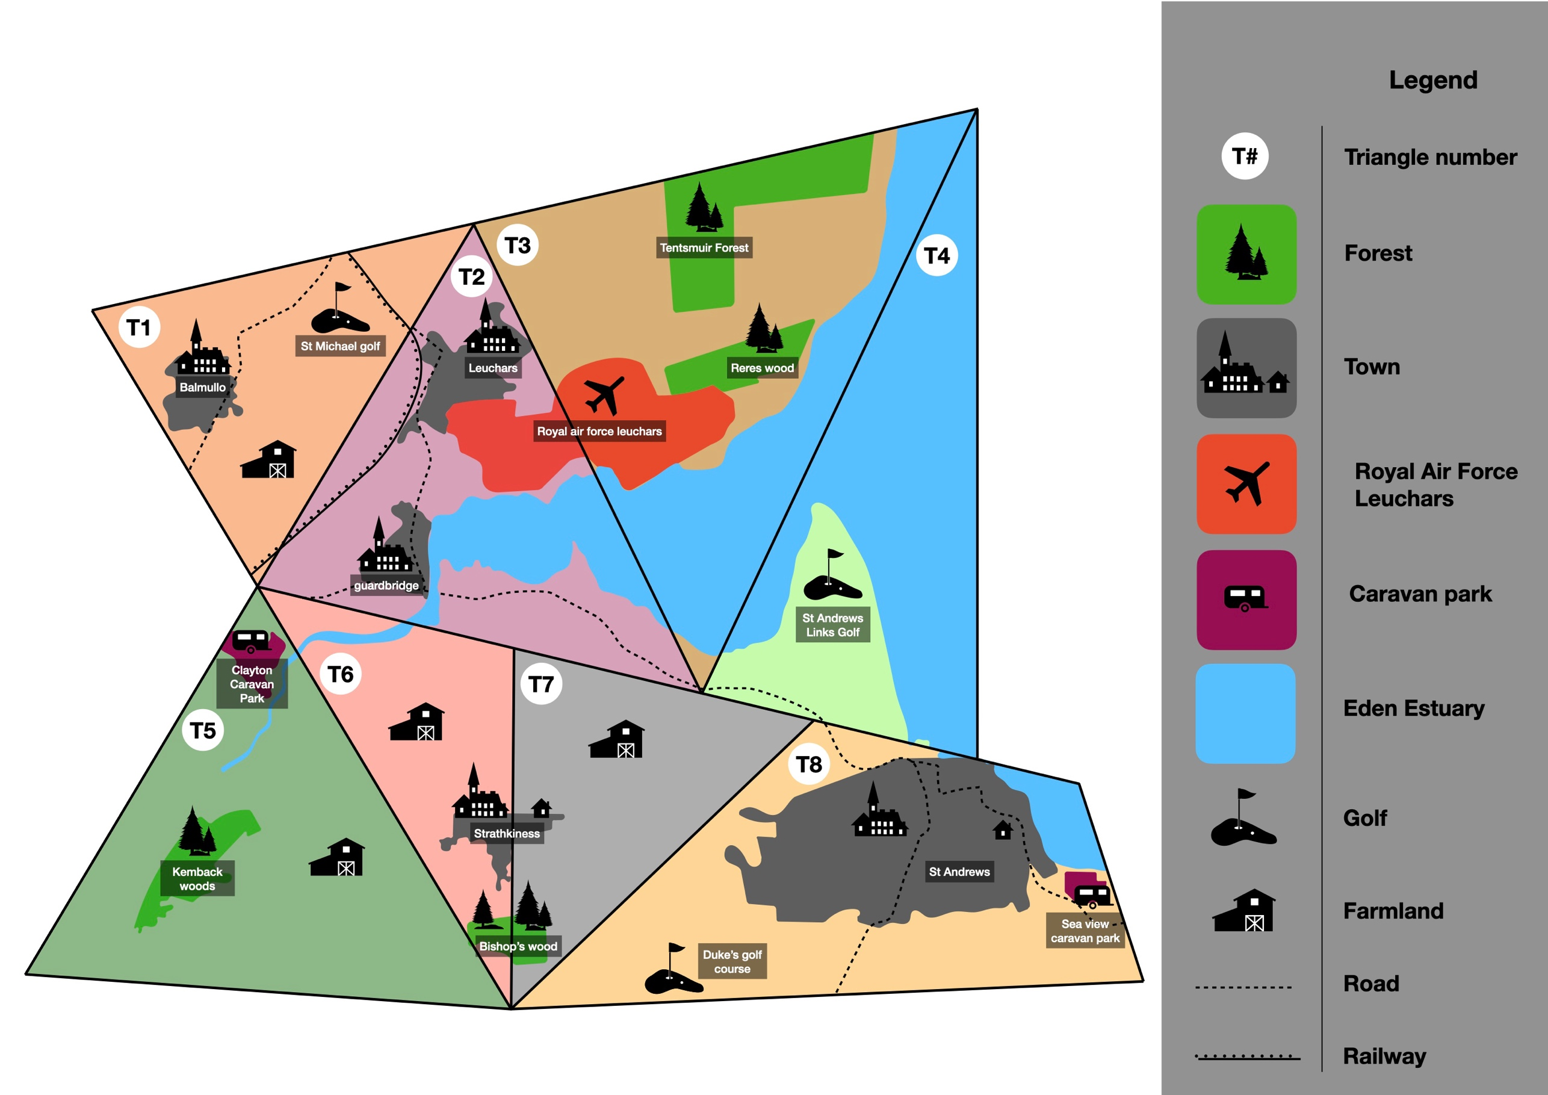
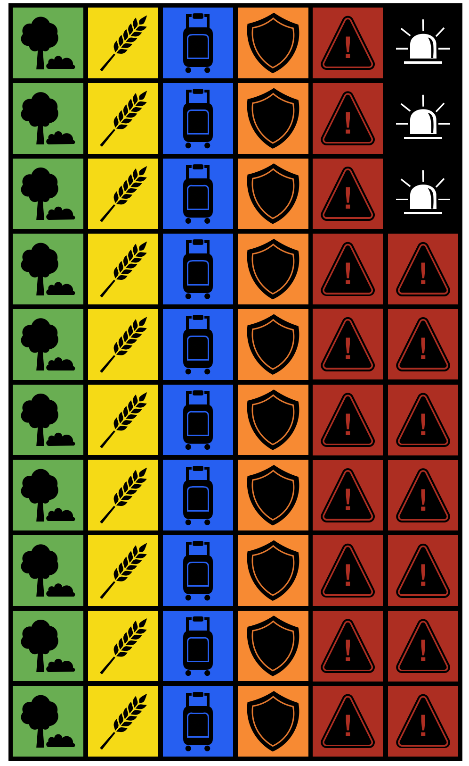
TYPES OF TOKENS

Conservation Program
This token enables to protect and preserve the surrounding nature and biodiversity. Such programs make the area more resilient to environmental hazards. Those might compete with social and economic factors.

Agricultural Development
This token enables to develop the agricultural sector in the area, enhancing economic development and guaranteeing good work conditions for farmers. However, this could bring further stress on the environment.

Tourism development
This token aims to develop the tourism sector in the area. This benefits the community and the economy. Nevertheless, this can be a double-edge knife and could create environmental and social stresses.

Disaster Risk Reduction
This token makes the area more resilient to social, economic, and environmental hazards. It enables to limit the damage caused by a hazard.

Disaster relief
Those tokens are special and enable to decrease the number of hazards per tile to avoid a crisis.
- Use 1 on a tile 1-3 hazards: -2 hazards
- Use 1 on a tile 4-5 hazards: -1 hazard

Hazard
Those depict the hazards which are present in the area.

REFERENCES

Corbett, P., Laughlin, A. (2022) Local Economic Profiles 2021-2022. Fife council. Available online at: https://know.fife.scot/__data/assets/pdf_file/0027/472626/Fife-Local-Area-Economic-Profiles-December-2022.pdf
Cunningham, C. and Hunt, C. (2023). Scottish Blue Carbon - a literature review of the current evidence for Scotland’s blue carbon habitats. NatureScot Research Report 1326.
Den Haan, R. J., van der Voort, M. C., Baart, F., Berends, K. D., van den Berg, M. C., Straatsma, M. W., Geenen, A. J. P., & Hulscher, S. J. M. H. (2020). The Virtual River Game: Gaming using models to collaboratively explore river management complexity. Environmental Modelling and Software, 134. https://doi.org/10.1016/j.envsoft.2020.104855
Fife Biodiversity Partnership. (2013). Fife Local Biodiversity Action Plan 2013-2018. Fourth edition. Available at:http://www.biodiversityscotland.gov.uk/
Fife Coast & Countryside Trust (2019) About Us, Fife Coast & Countryside Trust. Available at: https://fifecoastandcountrysidetrust.co.uk/about-us/ (Accessed: 11 December 2023).
Fife Coast & Countryside Trust. (2023) Eden Estuary Nature Reserve, Fife Coast & Countryside Trust. Available at: https://fifecoastandcountrysidetrust.co.uk/walks/local-nature-reserves-others/eden-estuary-nature-reserve/ (Accessed: 11 December 2023).
Fife Council. (2022) Community benefits – a guide for suppliers. Available at: https://www.fife.gov.uk/data/assets/pdf_file/0029/164567/Community_Benefits_Guide_2022_Final.pdf (accessed: 11 December 2023)
Fife Council. (2023) Council performance, Fife Council. Available at: https://www.fife.gov.uk/kb/docs/articles/about-your-council2/council-performance (Accessed: 11 December 2023).
Fife Golf Trust. (2023) Home, Fife Golf Trust. Available at: https://fifegolftrust.co.uk/ (Accessed: 11 December 2023).
Fife.gov. (2023) Tackling poverty and preventing crisis. Our Fife - Creating a successful, confident and fairer Fife. Available at: https://our.fife.scot/plan4fife/tackling-poverty-and-preventing-crisis (Accessed: 11 December 2023).
NatureScot. (2020) Arable farming, NatureScot. Available at: https://www.nature.scot/professional-advice/land-and-sea-management/managing-land/farming-and-crofting/types-farming/arable-farming#:~:text=winter%20wheat%20and%20winter%20barley,mainly%20in%20Tayside%20and%20Fife (Accessed: 11 December 2023).
NFU Scotland. (2023) About NFUS, About NFUS | About National Farmers Union, Scotland. Available at: https://www.nfus.org.uk/about-nfus.aspx (Accessed: 11 December 2023).
Rennie, A., Hansom, J., Hurst, M., Muir, F., Naylor, L., Dunkley, R., MacDonell, C. (2021) Dynamic Coast: Adaptation and Resilience Options for St Andrews Links. Scotland’s Centre of Expertise for Waters (CREW). Available online at: https://www.dynamiccoast.com/files/dc2/_DC2_WS4_StAndrews_FINAL.pdf
Royal Air Force. (2023) Leuchars station, Royal Air Force. Available at: https://www.raf.mod.uk/our-organisation/stations/leuchars-diversion-airfield/ (Accessed: 11 December 2023).
University of St Andrews. (2023) Vice-principal (international), Senior Vice-Principal (International) - About - University of St Andrews. Available at: https://www.st-andrews.ac.uk/about/governance/principal/principals-office/international/ (Accessed: 11 December 2023).
VisitScotland. (2023) Fife - accommodation, things to do & holidays, VisitScotland. Available at: https://www.visitscotland.com/places-to-go/kingdom-fife (Accessed: 11 December 2023).

